Lithium-ion battery
recycling

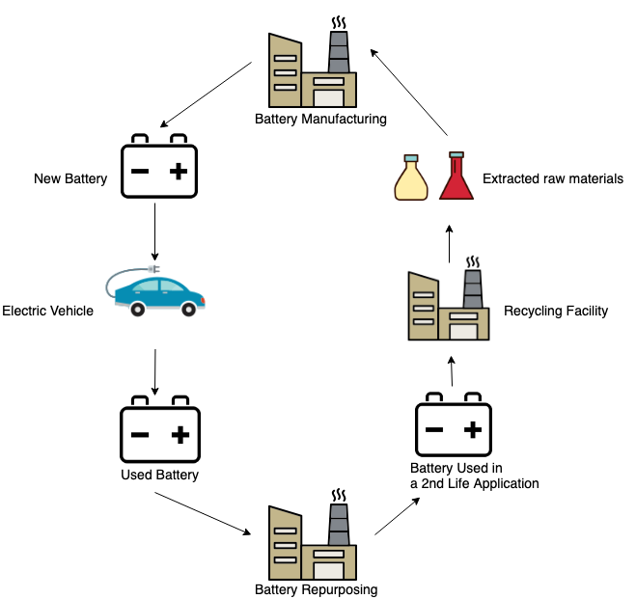
We are able to recycle over 80% of lithium-ion battery materials. Our industrial-scale, low-CO₂ process allows us to recover lithium, cobalt, manganese and nickel from the battery for reuse in producing new batteries.

To achieve a high recycling rate of 80% with a low-CO₂ we use hydrometallurgical recycling process. The lithium-ion batteries are first made safe for mechanical treatment, with plastics, aluminium and copper separated and directed to their own recycling processes. And what is left of the battery after these processes are the chemical and mineral components, the ‘black mass’ and in our facility in Harjavalta the ‘black mass’ can be treated on an industrial scale.

The black mass typically consists of a mixture of lithium, manganese, cobalt and nickel in different ratios. Of these, nickel, cobalt and lithium are the most valuable and most difficult to recover. Most of today’s recycling solutions for EV batteries are not able to recover these valuable minerals.

The hydrometallurgical recycling process involves a chemical precipitation methodology that allows scarce minerals to be recovered and delivered to battery manufacturers for reuse in the production of new batteries. This technology was developed by the Finnish growth company CrisolteQ that was acquired by Fortum in January 2020.

Recycling of lithium-ion battery materials is the key for growth in electric transportation

In the future, battery components will not be sourced solely from mining; they will have to come from recycling and from applications utilising industrial side streams. The ability to recover these materials will drive the increase in electric vehicles.

